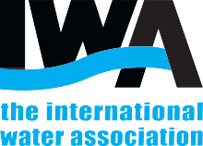
15th IWA Specialised Conference on Design, Operation and Economics of Large Wastewater Treatment Plants (LWWTP 2027)

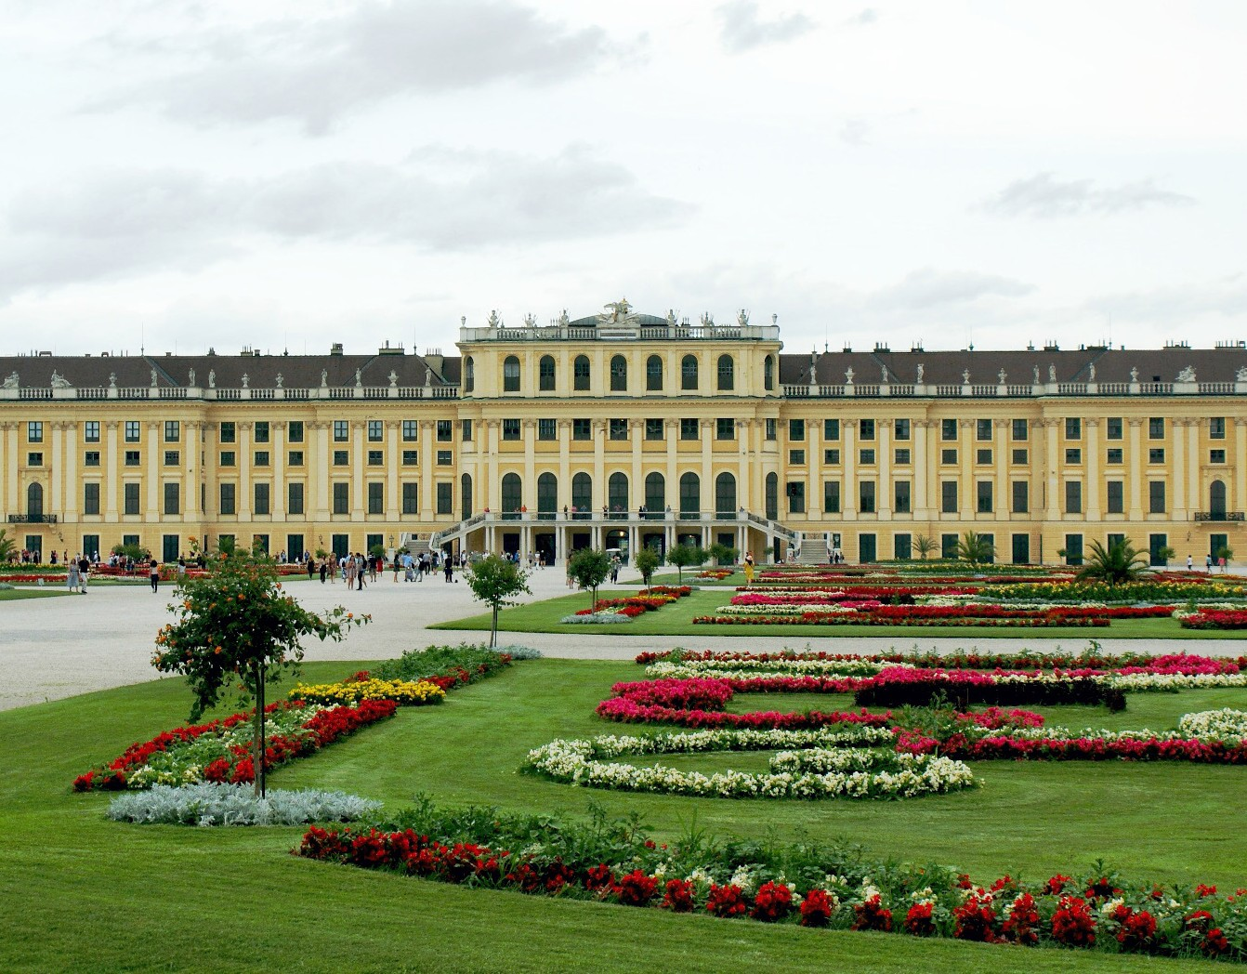

ORGANISED BY THE IWA SPECIALIST GROUP ON DESIGN, OPERATION AND COSTS OF LARGE WASTEWATER TREATMENT PLANTS
1st Announcement and
Call for Paper
12 – 16 SEPTEMBER, 2027
VIENNA, AUSTRIA

lwwtp2027.org
Foto: © Joseph Tauber

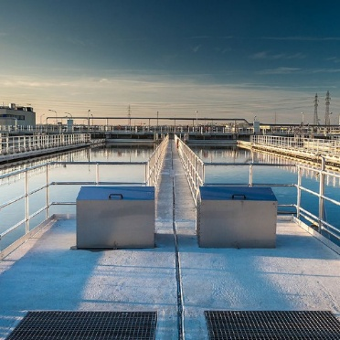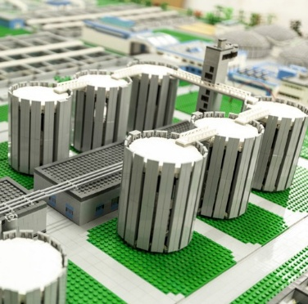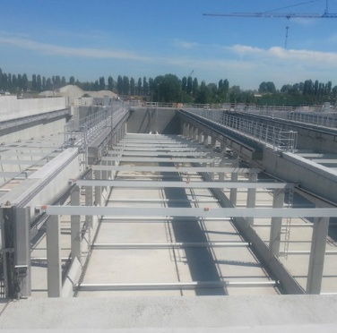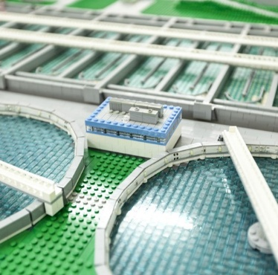
Foto: © Christian Houdek
Foto: © Christian Houdek
Foto: © Joseph Tauber
Foto: © Christian Houdek

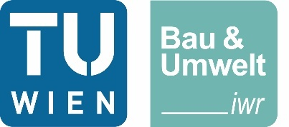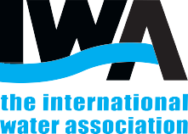

1st announcement
& Call for Papers

WELCOME TO VIENNA

On behalf of the International Water Association (IWA), its Specialist Group on Design, Operation and Costs of Large Wastewater Treatment Plants, and the Institute for Water Quality and Resource Management at TU Wien, it is our pleasure to invite you to join us for the IWA Specialized Conference “Design, Operation and Economics of Large Wastewater Treatment Plants” from September 12th to 16th, 2027 in Vienna.

After the last conference in Budapest 2024, Vienna looks forward to hosting the 15th conference in this series. The programme will focus on all aspects of the design and operation of large wastewater treatment plants, including economic factors and emerging topics arising from the revised EU Urban Wastewater Treatment Directive. It will also discuss research and technology for future-oriented WWTPs, focusing on AI applications in WWTP design and operation, energy system integration, nutrient recovery, sustainability aspects, and water reuse. It will bring together operators, designers, and consultants on one side, with researchers, developers, and technology providers on the other side.

Special emphasis will be placed on the active participation of young water professionals. The conference will provide a forum to discuss novel approaches and share practical experiences spanning the whole range from the design and operation of large wastewater treatment plants to concepts for future-oriented wastewater management.

Vienna is always worth a visit with its numerous cultural highlights and as home of one of the largest sewage treatment plants in Europe. A technical tour will take place on the last day of the conference.
We cordially invite you to join us for this conference and are looking forward to an inspiring event.

Conference Chair

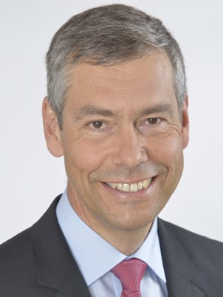
Prof. Dr.-Ing. Norbert Jardin
Past Chairman of the IWA Specialist Group on Design, Operation and Costs of Large Wastewater Treatment Plants

Conference Chair

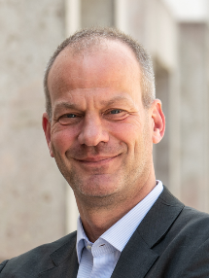
Prof. Dr.-Ing. Jörg Kramp
Chairman of the IWA Specialist Group on Design, Operation and Costs of Large Wastewater Treatment Plants
Head of Research Unit of Water Quality Management, TU Wien

INVITATION TO THE CONFERENCE

BACKGROUND

The conferences on Large Wastewater Treatment Plants (LWWTP) are the most traditional specialized conferences organized by IWA specialist groups. The first conference (at that time called “workshop”) was held in Vienna and repeated in four-year periods. Since 1987, it is also hosted in Budapest and Prague. The conference has always been a good place to meet with leading experts from Europe, the USA, Canada, Australia, South Africa, Latin America, Asia, and many other parts of the world.

The papers submitted for presentation at the conference are evaluated by the conference's Scientific Committee (SC). The SC of the LWWTP conference is a well-established body of internationally recognized specialists. For the conference in 2027, new professionals were added to the committee, which also helps to broaden the expertise. The main task is to guarantee that all accepted papers for both oral and poster presentations will meet the high scientific and technical standards typical for this traditional conference.

The final structure of the programme will be decided by the conference chairs and the programme committee based on the SC's reviews. They will also be assisted by a group of young water professionals.

SCOPE OF THE CONFERENCE

All the conferences on Large Wastewater Treatment Plants within the last 50 years have been dedicated to the cost-effective solution of practical issues in the design and operation of large wastewater treatment plants. They have been successfully conducted in the form of workshops. An equal amount of time was allotted for presenting the papers and discussing them with the issues particularly interesting for large works. This workshop character created a unique and open atmosphere in which experts from around the globe started becoming a family. Although times have changed since the start, we will continue this tradition. Apart from the oral presentation stream, we will prepare small workshops on current topics related to large wastewater treatment plants for the conference participants.

The scientific programme is based on talks by multiple keynote speakers and accompanied by a poster session. The poster session is always a suitable forum for the discussion and idea exchange of the conference participants with poster authors. The management committee will select and name the conference’s best poster to encourage young experts to participate in the poster session. The winner of this contest will be announced at the conference closing ceremony.

The conference will start traditionally on Sunday evening with registration and the “Meet and Greet”. During the conference evenings we are planning social activities like a “poster party” with the discussion around the exhibited posters and a conference gala dinner on Tuesday evening. The scientific programme and the workshops are scheduled for three days. On the fourth day, there will be an optional technical tour to the Vienna wastewater treatment plant (4 Mio. PE).

ABSTRACT SUBMISSION

Authors are invited to submit an abstract according to the outline on the conference website before September 30th, 2026. The procedure, as well as the template for submission, is available on the official conference website: www.lwwtp2027.org

All submissions should be original and not have been previously accepted for publication in a journal. Authors whose abstracts are selected will be invited to give an oral or poster presentation at the conference. The authors will be notified of acceptance by February 28th, 2027.

KEY DATES

First announcement and call for abstracts:
January 19 th 2026
Deadline for submission of extended abstract: September 30th 2026
Date for notification of successful authors:
February 28th 2027
Deadline for submission of revised extended abstracts:
May 31st 2027
Early Bird registration before:
June, 1st 2027

CONFERENCE TOPICS

PURPOSE AND SUBJECTS

The Vienna 2027 edition will continue the long-standing tradition of bringing together engineers, scientists, operators, and decision-makers from all over the world to share insights on the design, operation and costs of large wastewater treatment plants.

As cities continue to grow and climate change places increasing pressure on critical infrastructure, the role of large wastewater treatment plants is undergoing a profound transformation. No longer viewed merely as the endpoint of urban water cycles, these facilities are becoming integral to building resilient and sustainable cities. The conference will reflect this evolution by addressing how LWWTPs can be designed and operated to respond flexible to changing loads, extreme weather events, and stricter regulatory demands. The growing integration of climate adaptation, energy recovery, and resource efficiency will be key themes, alongside real-world strategies for ensuring long-term reliability. The digital transformation of the sector will also be in the spotlight. Topics range from real-time process optimization and AI-assisted decision-making to the practical deployment of smart systems.

Join us in Vienna to shape the future of large wastewater treatment – innovative, adaptive, and sustainable.

  - Design & operation of large WWTPs
    - wastewater treatment in large cities
    - appropriate technologies for developing countries
    - strategies for achieving low effluent nutrient level
    - crisis management (e.g. blackout, supply chain…)
    - WWTP resilience to climate change (e.g. floods)
    - instrumentation, control, automation & cyber security
    - construction and investment cost optimization
    - CFD & process modelling

  - Management, monitoring & reporting
    - asset management and strategic planning
    - cost implications and funding mechanisms for plant upgrading
    - benchmarking
    - monitoring & reporting for GHG emissions on WWTPs

  - Sewage sludge handling
    - modern approaches to sludge processing
    - energy recovery
    - reject water treatment
    - sludge incineration & phosphorous recovery

  - Optimisation of large WWTPs
    - implementation of advanced wastewater treatment technologies
    - organic micropollutant removal
    - use of membranes in wastewater treatment
    - intensification of treatment (granular sludge, attached growth, hybrid systems)
    - cost- and energy-effective operation

  - Future-oriented technologies
    - energy system integration for large WWTPs (sector coupling)
    - AI applications in WWTP design and operation
    - retrofitting and plant upgrading to meet new regulations
    - nutrient recovery
    - water reuse

TECHNICAL TOUR

The technical tour to the Vienna wastewater treatment plant is planned for the last day of the conference.

CONFERENCE LANGUAGE

The official language of the conference will be English. There will be oral and poster presentations.

PROGRAMME OUTLINE

Sun. 12-09 Welcome reception and registration Mon. 13-09 Scientific programme
Tue. 14-09 Scientific programme and Gala Dinner Wed. 15-09 Scientific programme
Thu. 16-09 Technical tour - Vienna WWTP

REGISTRATION FEES

Non IWA IWA YWP Spouse member member member
Early Bird registration – before June 1st 2027

High-income country | 600 | 500 | 250 | 230
Low-income country | 500 | 400 | 200 | 200
Late registration – after June 1st 2027
High-income country | 680 | 580 | 300 | 230
Low-income country | 520 | 420 | 250 | 200

CONFERENCE COMMITTEES

SCIENTIFIC COMMITTEE

Santo Fabio Corsino, Italy

Oliver Das, Germany

Andreas Giesen, The Netherlands

Sylvie Gillot, France

Norbert Jardin, Germany

Jose Jimenez, USA

Harald Kainz, Austria

Jörg Krampe, Austria

Helmut Kroiss, Austria

Susanne Lackner, Germany

Winson Lay, Singapore

Marjetka Levstek, Slovenia

Mark van Loosdrecht, The Netherlands

Jacek Makinia, Poland

Norbert Matsché, Austria

Vanessa Parravicini, Austria

Miklos Patziger, Hungary

Leiv Rieger, Canada

Diego Rosso, USA

Jan Ruppelt, Germany

Julian Sandino, USA

Kim Helleshøj Sørensen, Sweden

Martin Srb, Czech Republic

Imre Takacs, France

Michele Torregrosa, Italy

Nerea Uri Carreño, Denmark

Jiri Wanner, Czech Republic
CONFERENCE CHAIRS AND PROGRAMME COMMITTEE

Conference Chairs
Norbert Jardin, Germany
Jörg Krampe, Austria

Programme Committee

Norbert Jardin, Germany

Jörg Krampe, Austria

Helmut Kroiss, Austria

Vanessa Parravicini, Austria

Miklos Patziger, Hungary

Martin Srb, Czech Republic

Jiri Wanner, Czech Republic

Young Water Professionals

Oliver Das, Germany

Kilian Deinhammer, Austria

Kara Kobsik, Austria

Maximilian Wukovits, Austria

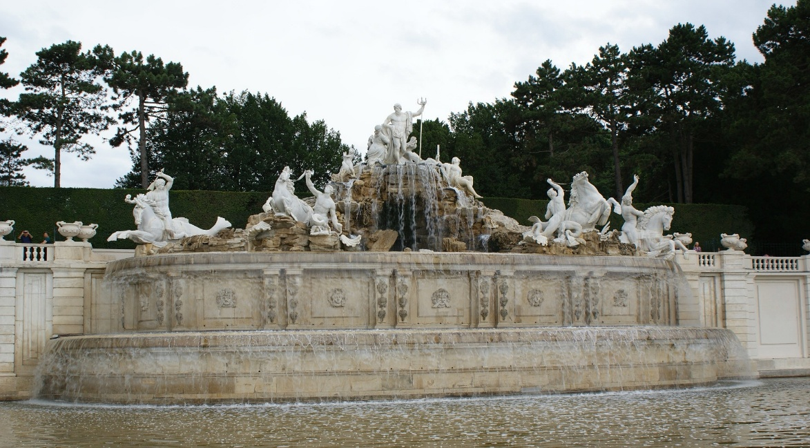
Foto: Joseph Tauber

innovating technology, pioneering science, connecting people, leading practice, inspiring change. pioneering science, connecting people, leading practice, inspiring change. pioneering science, connecting people, leading practice, inspiring change. pioneering science, connecting people, leading practice, inspiring change.innovating technology, connecting people, leading practice, inspiring change. pioneering science, connecting people, leading practice, inspiring change.innovating technology, pioneering science, leading practice, inspiring change. pioneering science, connecting people, leading practice, inspiring change.innovating technology, pioneering science, connecting people, inspiring change. pioneering science, connecting people, leading practice, inspiring change.innovating technology, pioneering science, connecting people, leading practice, innovating technology, pioneering science, connecting people, leading practice, inspiring. pioneering science, connecting people, leading practice, inspiring change. pioneering science, connecting people, leading practice, inspiring change. pioneering science, connecting people, leading practice, inspiring change.innovating technology, connecting people, leading practice, inspiring change. pioneering science, connecting people, leading practice, inspiring change.innovating technology, pioneering science,

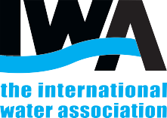

TU Wien
Institute for Water Quality and Resource Management
address Karlsplatz 13/2261
1040 Vienna Austria
phone + 43 1 58801 22611
email sekretariat@iwag.tuwien.ac.at

IWA Global Operations

address UK Head Office
Export Building, First Floor
1 Clove Cresent
London E14 2BA
UK
phone + 44 207 654 5500
email water@IWAhq.org
inspiring change

IWA Head Office | Export Building, First Floor, 1 Clove Crescent, London E14 2BA, UK | Company registered in England No. 3597005 | Registered Charity (England) No. 1076690

